Here we will walk through everything you need to get a basic Ansible multi-node environment up and running. Which packages, how to configure and then deploying and managing the user account we need.

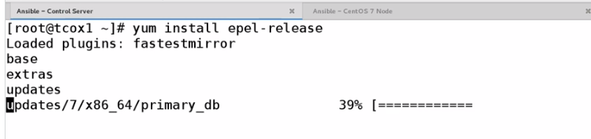

Then do yum update

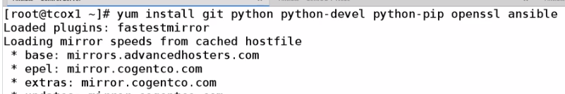

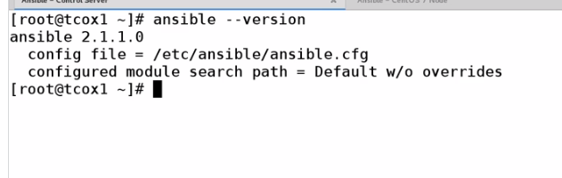

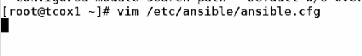

Uncomment that two line

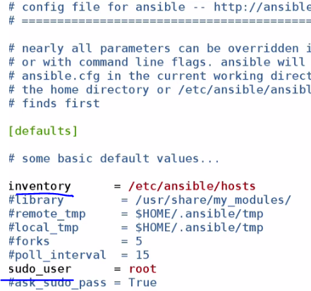

Set basic host file to understand the node

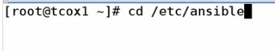

cat hosts provide the example of host file

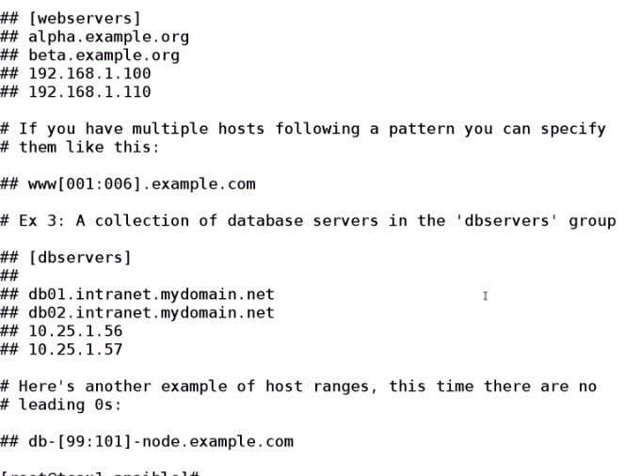

Now we gona create a simple host file



vi hosts

gonna setup 3 group

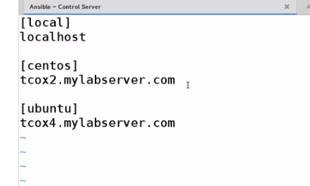

**User Accounts**

Create a user called *ansible* (example) on the server you intend to use Ansible to run playbooks from AND

each of the Ansible nodes you intend to run playbooks on. Set the user as a sudo-capable user and include

the NOPASSWD: ALL directive in */etc/sudoers*.

Create an SSH key with *ssh-keygen* on the Ansible server. Exchange that key using *ssh-copy-id* on each

of the nodes you are running playbooks on. This allows the playbook to run with escalated privileges as needed

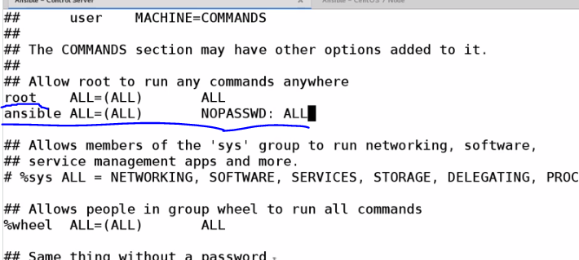

As ansible user not only require sudo also required no password.

Set-Up ssh key exchange for no password



Copying key to the other node so ,next time will not ask password for ssh

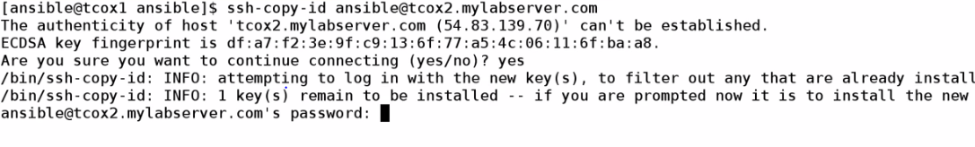

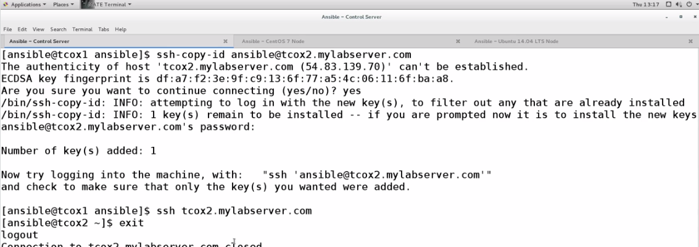

That need to done in all node …including local machine

..also in

